**Online Textbook & Online Homework**

**Instructions**

**Accessing the website**

1.) Go to Clever.com

2.) Click "Login" at the top right

3.) Choose login as a student

4.) Search for Perry High School

     *do not hit enter right away, wait for the list of schools to drop down after typing

      *be sure to choose Perry High School, Chandler Unified District

5.) Click Login

6.) Login to Clever

        Username: **S + student id + @cusd (the “S” IS capitalized)**

      Password**: s + student id + ! (the “s” is NOT capitalized)**

Ex. usersname: S123456@cusd

      password:   s123456!

7.) Click on the Big Ideas Logo

**Online Textbook**

* Your textbook is called your “Student Dynamic EBook” and can be found under the resources tab
* You can open the textbook from your website each day or you may also download this EBook to any tablets or computers at home
* You may highlight, make notes, and save bookmarks in your EBook

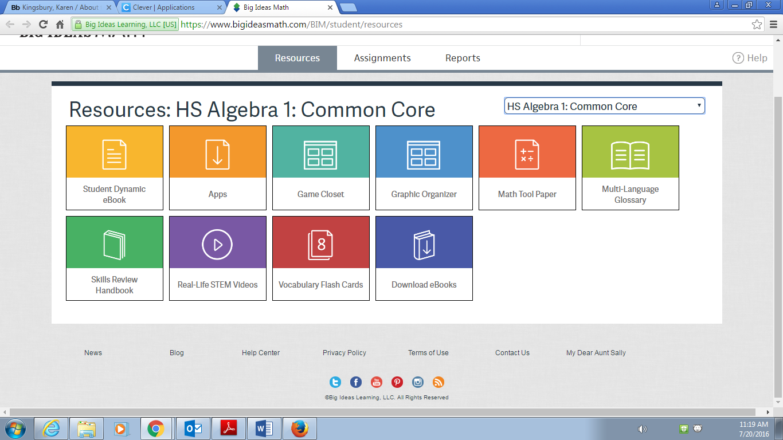

**Online Assignments**

* Your online assignments are found under the assignments tab.
* Click “Enter” to begin your assignment.

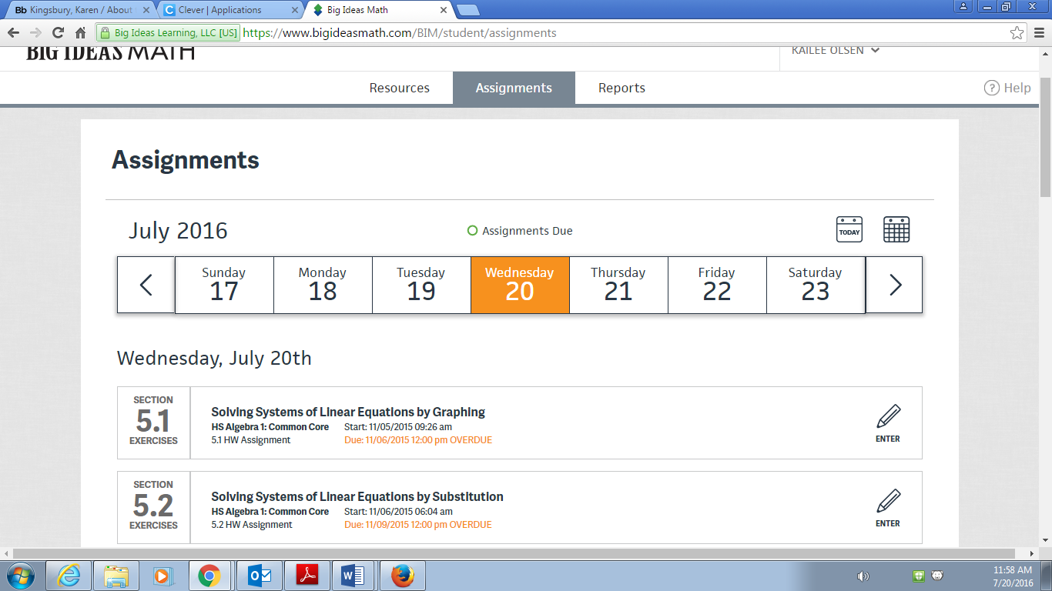

* After completing each problem on the online homework, be sure to click the “Check Answer” button to see if your answer is correct. If your answer is incorrect, you have an infinite number of chances to get the correct answer. You may use the “Help” button at any time, which will provide you with similar examples, videos, or an online chat with a live tutor.
* Some hints to help you:
  + Pay attention to directions for what form your answer should be in.
  + If your answer is incorrect and there are multiple ways to write your answer, check your work and if you still think it’s correct, try another form for your answer. Ex: you may write $\sqrt{40}$ but they want the simplified version, $2\sqrt{10}$, or the rounded decimal version.
  + Do NOT round repeating decimals unless instructed to do so. Enter the fraction version instead.
  + Do NOT round in the middle of a multi-step problem. When asked to round, wait until the very end of the problem to round your final answer. If you absolutely have to round mid-way through a problem, be sure to write down 5-6 decimal places in order to get the most accurate answer at the end.
* It is a smart idea to get in the habit of saving your assignment a few times throughout the assignment. When you click on your name in the top right corner, a drop box with options to save, exit, print, and submit will pop up.
* Prior to submitting your assignment, it is highly recommended that you save your file as a PDF (click print, change printer to “save as PDF”), which will be time-stamped and can be emailed to your teacher if there are ever any issues with your assignment being turned in on-time.
* To submit your assignment, click on your name and choose “submit” from the drop-down box. If you did not receive a score in the form of a percent, then your assignment wasn’t successfully submitted.
* Once you submit your assignment, there’s no way to un-submit it without talking to your teacher. However, you may look at & review all of your submitted assignments by clicking on the “Reports” tab.

**Grading**

|  |  |
| --- | --- |
| **% Grade on**  **Assignment** | **# Points For**  **Gradebook** |
| 88-100 | 4 |
| 63-87 | 3 |
| 38-62 | 2 |
| 13-37 | 1 |
| 0-12 | 0 |

* Upon submitting your online assignment, you will receive a score in the form of a percent. This is score is based on both accuracy and completion. The following table will be used to convert this score into points for the gradebook.
* In addition to submitting your online assignment, you are also required to show your work on a separate piece of paper.
  + You may use the same piece of paper for work for multiple assignments, as long as the paper is neat and organized.
  + Each section’s work should be clearly labeled and a space should be left between sections.
  + Within each section, **work must be numbered based on the exercise number** that corresponds to the problem’s number in the textbook (**NOT** the number in blue on the left side of the page).

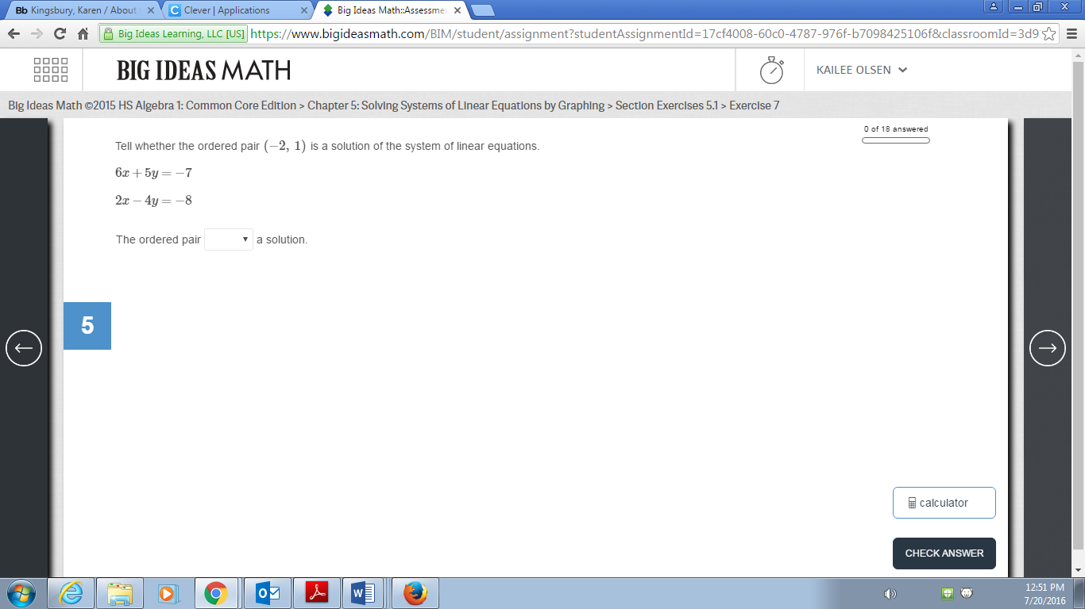

This number just tells you it’s the 5th problem of your assignment

Use THIS number to number your work for each problem!

* Your work packet will be collected at the end of each chapter, on the test day. It should already be organized, labeled, and stapled before you arrive to class that day.